**Mechanism Description of Strawberry Stem Hullers**

**Presented to Dr. Grenier**

**By George Mavroeidis**

**ID #: 40065356**

**A Technical Report**

**submitted in fulfillment of the**

**requirements of ENCS 282**

**Concordia University**

**February 12th 2019**

**1.0 INTRODUCTION**

A strawberry stem huller [1] is a kitchen tool made for the removal of the stem and leaves from strawberries without peeling off any edible strawberry flesh. Its function is to facilitate the cutting process of the strawberries efficiently, while keeping the fruit fresh and whole. Its appearance consists of a T-shaped red plastic casing, with a green plastic knob on top of it. The metal shiny claws and the green button are connected through an aluminum spring and held tight by a green plastic screw, perpendicular to the casing. All the parts have a smooth finish, except the casing, having minor roughness on its surface. When the knob is pushed down, the four claws open so they can grip into the strawberry and hold it tight. When twisted and pulled, the strawberry’s stem and leaves are removed without crushing the rest of the fruit. The tool is separated into five different parts: the casing, the claw, the button and the spring.

**Strawberry Stem Huller**

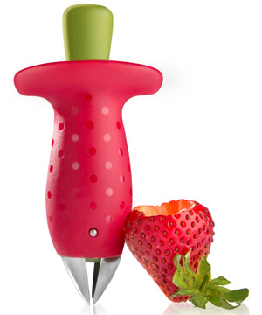

**Strawberry Stem Huller next to a strawberry [1]**

**2.0 DESCRIPTION OF MAIN PARTS**

**2.1 The Casing**

First, the casing is a cover that encloses the mechanism of the tool. Its purpose is to protect the tool’s interior and provide a convenient way for the user to handle it. Its T-shaped cylindrical appearance allows the user to handle the tool with one hand. The casing is built with a red plastic coating with shiny dots around the lateral area. Its length is 57mm with a maximum radius of 10mm. Its perpendicular width reaches a maximum of 47mm. The overall texture and finish contain minor roughness with shiny spots within the dots. A green plastic cap [2] seals the bottom part of the casing, allowing for the claw to exit the casing. In addition, it is a device that limits the depth of the claws inside the strawberry. Its purpose is to not allow the claw to enter too deep into the strawberry and remove the edible flesh. It is wielded with the red case. Therefore, it is not considered a separate item. For additional contact, two holes in the middle of the casing [2] exist in order to contain the edges of the cap rigid. The index and middle finger are placed under the corners of the T-shaped red casing in order to create resistance for the button to be pressed [3]. Inside the casing, the button and the claw are connected, where the mechanism of the tool holds. At the top of the casing, a circular hole exists for the button to be pressed.

**2.2 The Button**

The button is a knob that can be pressed in order to initialize a mechanism or an action from another part. In this tool, its purpose is to compress the spring and open the claw at the bottom of the casing [3]. When released, the button moves up, the spring reverts back to its original form and the claw closes. It has a hollow cone-cylindrical shape with an open end at the bottom. It is built with a green plastic coating with a lightless finish and smooth texture, unlike the roughness of the casing. It Is lightless, because it projects minimal amount of reflection. The button has a maximum radius of 7mm and a lateral length of 22mm. An additional round cap is placed on top of the part, being wielded tight for improving the comfort of the user’s thumb when placed. When used, the thumb is placed on top of the button in order to push it down. The spring becomes compressed and mechanism commences.

**Strawberry Stem Huller – Close Up**

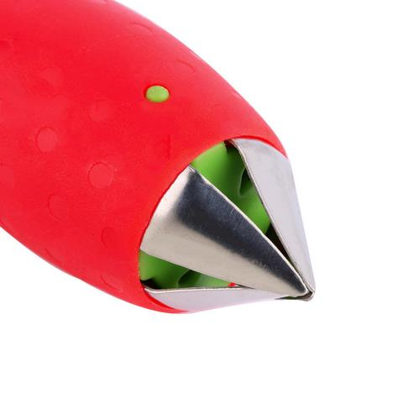

**Strawberry Stem Huller claw and front cap [2]**

**2.3 The Spring**

The spring is a helical, spiral metal coil that exerts constant tension when compressed and can be released back to its original form when decompressed. In this tool, it provides a harmonic motion, where the claw opens when it is compressed [3]. When the button is released, the spring becomes decompressed and the claw closes. It has a helical shape and it is thinner than a millimeter. It has a radius of 2mm and a length of 14mm. It is placed within the casing and it is attached between the claw and the button. It is made out of gray spring steel with a smooth texture and a glossy finish. The compression allows the claw to open so they can attach to the strawberry.

**Strawberry Stem Huller – Side View**

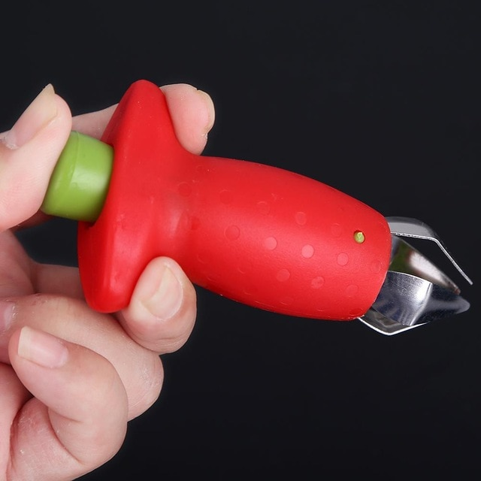

**Strawberry Stem Huller in an extended state by hand [3]**

**2.4 The Claw**

The claw [2] is a device consisting of sharp, curved edges that open and close. This movement allows it to latch onto something, making it unable to move. Its purpose is to dig onto the strawberry’s stem, hold it tight and rip it off when the tool is pulled and twisted. Its shape consists of a thing circular ring with five knives pointing downward perpendicularly to the casing. The knives can easily cut through the strawberry without destroying its flesh. When the spring is compressed, the knives detach from one another and move out from the casing, allowing them to open up. When the spring is released, the knives are collected and stored back inside. The ring has a radius of 7mm, which is a few millimeters smaller than the casing, allowing it to be stored inside of it. When the claw is closed, it has a length of 70mm. When extended, it has a maximum length of 78mm. The claw is made out of a thin aluminum sheet, making it flexible and bendable. It is shiny and glossy and has a smooth finish.

**3.0 CONCLUSION**

In conclusion, the strawberry stem huller is used to remove the stem and leaves from strawberries. It consists of the casing, the claw, the button and the spring. The casing covers and holds all the parts together and provides cover for the internal mechanism. The button allows the user to initialize the mechanism and compress the spring. The spring provides a harmonic and elastic motion for the claws and the button, while simultaneously connecting them. The claw consists of sharp knives that dig inside the strawberry and remove the stem when pulled and twisted. For people who eat berries and strawberries on a daily basis, this tool will reduce the time for the cutting process. It could be an unnecessary tool, but its appearance, safety and cuteness make it worthy for the kitchen.

**4.0 REFERENCES**

[1] VANT19 (2014). *Strawberry Stem Extractor - Front*. [image] Available at: <https://www.vat19.com/item/stem-gem-strawberry-huller-stem-remover> [Accessed 10 Feb. 2019].

[2] SupaCuteDesserts (2014). *Strawberry Stem Extractor Close-Up*. [image] Available at: [https://www.supacutedesserts.com/products/strawberry-huller](https://www.supacutedesserts.com/products/strawberry-huller%20) [Accessed 10 Feb. 2019].

[3] AliExpress (2014). *Strawberry Stem Extractor Extended*. [image] Available at: https://www.aliexpress.com/item/Kitchenware-Tomato-Stalks-Fruit-Strawberry-Knife-Stem-Remover-Strawberry-Slicer-Strawberry-Huller/32476734791.html [Accessed 10 Feb. 2019].